**Shadow Pages Playbook**

Here’s the full breakdown of how **Shadow Pages** work and how you can take advantage of the booming Creator Economy and make $5k to $10k per month…

**\*\*The Golden Opportunity Creators Are Using to**

Earn Passively Online**

In the last 5-10 years a new wave of millionaires hit…

And it’s not coming from traditional real estate, stocks or anything like that.

Social media has created millionaires out of the blue with the rise of platform like Instagram, TikTok and YouTube — normal people could start uploading content, get viewers and get paid (e.g. MrBeast, Kylie Jenner etc.)

And take advantage of the creator industry that Goldman Sachs expects to skyrocket to half a trillion by 2027👇🏼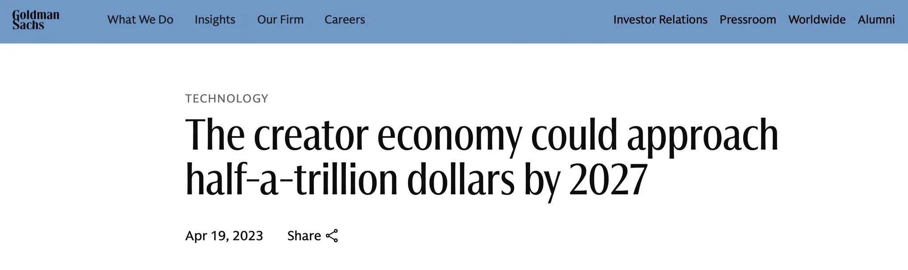

Yet the problem was you’d have to show yourself, lose all your privacy and at the same it took a lot of time to create content…

But now a new era has begun, where faceless creators are taking over — with Shadow Pages you don’t have to show yourself, be an influencer or even create any of the videos yourself…

You can profit of social media the same way all of these influencers do by selling advertisements, digital products - that you didn’t even create or partner up with big brands… (we’ll come to that later)

Even Forbes says that faceless creators are taking over 👇🏼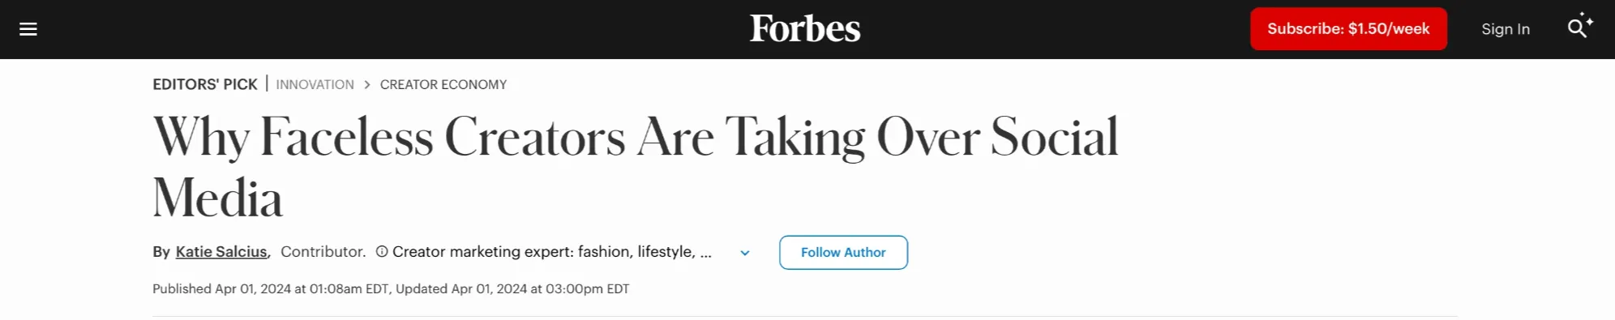

**Shadow Pages & how exactly regular people are using them to profit of the Creator Economy**

And the best part is, you can scale this as a real business because your Shadow Pages are not bound to your face, your voice or anything else meaning you can completely delegate all the work to cheap freelancers or leverage A.I. to do it all for you…

That way you can start as many pages as you’d like (e.g. I own 10+ pages simulatnously) and scale building multiple Shadow Pages and being able to profit 4-5 figures/mo with each one — while traditional creators or influencers can only focus on their own personal brand (that they cannot even sell).

With Shadow Pages instead - you can treat them as real assets… that can be sold, acquired and like already mentioned scaled. There are already Shadow Pages that gold sold for tense of millions of dollars just like the meme page daquaan which Warner Studios acquired for $85M 👇🏼

Once I figured out the system, everything changed.

I stopped just watching creators win and started winning myself.

**And this is just the start… but what exactly is a Shadow Page you may ask?**

Think of Shadow Pages as Instagram accounts that are all about a specific niche or topic, not a person. The page itself is the brand. You most likely follow a bunch of them — We’re talking about those popular accounts you see posting content on motivation, business, gym life, spirituality, weird facts - you name it.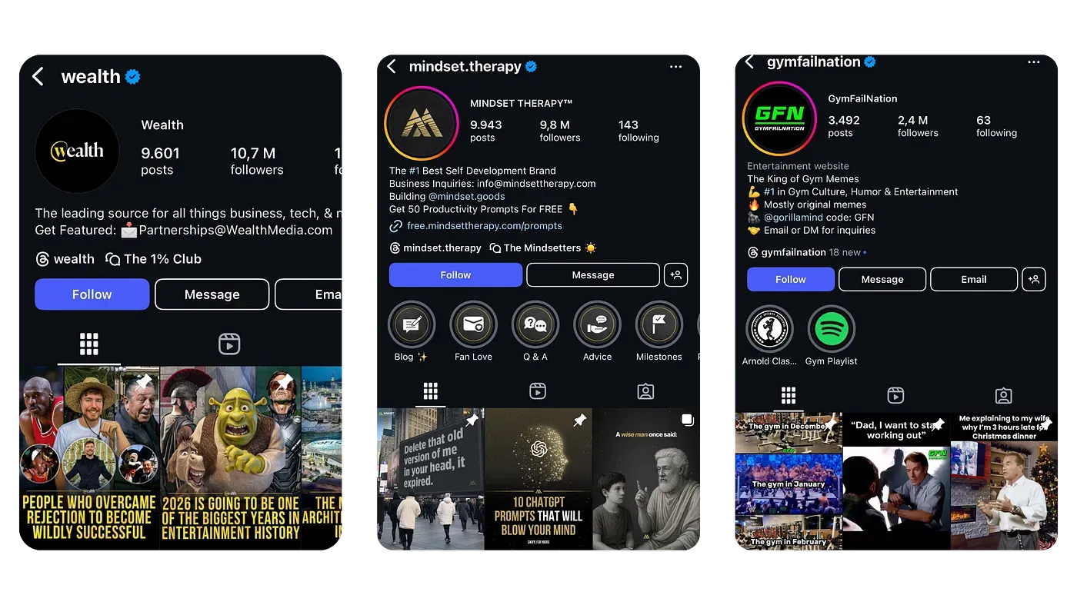

Pages like @wealth, @mindset.therapy @pubity or @gymfailnation…

These pages grow by posting niche specific, high engagement content - all without showing the person behind it. Most of the content is either reposted, created with AI, or outsourced to cheap freelancers.

That keeps time and cost low. As a result, many page owners keep 90–95% of the profit and scale by running multiple pages at once, almost fully automated.

**But How Do Shadow Pages Actually Make Money?**

We’ve already covered this a bit above — but let me now break it down even further so you can really grasp and understand it…

With Shadow Pages you have a lot of different ways how you can profit — here are my top 5 proven monetization methods to generate cashflow 👇🏼

1. Ads & Promos (Shoutouts): One of the simplest ways to start earning. Once your page has an engaged niche audience, businesses or brands will reach out & pay you to promote them. Even smaller pages can profit from this, and it’s completely passive.

Large pages sell shoutouts for thousands - and there's always demand as you’re growing niche followers that is extremely valuable and people trust. Meaning businesses are ready to pay huge sums to be able to advertise to that platform of viewers.

2. Affiliate Marketing: This is one of the best ways how you can profit when starting out as you can promote a proven product that someone else created and earn up to 80% commissions - without having to deal with customers support, inventory or even creating the product.

Many Shadow Page owners use this monetization method as it’s passive and head off. Inside our community we always share the hottest affiliate products with our students — to win all together.

3. Selling Your OWN Digital Products: High-trust = high profits. Once your audience connects with your content, you can sell ebooks, templates, guides, or courses. Margins are nearly 100% since you create once and sell endlessly. This is where you can profit the most later in your journey - but selling an affiliate product for the start is easier as you can allocate your time more on your Shadow Page when starting out while still generating cashflow.

PS: Though with A.I. creating a digital product is now easier than ever before. One of my students created an eBook by leveraging artificial intelligence to creating it and it ended up making him more than 6 figure since he started it.

4. Instagram’s Creator Fund & Bonuses: Instagram now pays creators for views via bonuses and incentive programs. You don’t need to sell anything - just post simple content and Instagram will pay you rewards for doing that and a bit of their advertising revenue. This is not a main income source, but it adds extra cashflow without doing anything extra.

5. Brand Deals & Sponsorships: As your page grows, brands may offer long-term collabs and higher-paying deals. This can go far beyond shoutouts - custom content, partnerships, and 5 figure monthly dreals are possible when your page has authority.

I’ve once partnered up with one of the biggest e-commerce companies in the world & got paid multiple 5-figures per month for a long duration of time. As I’ve already mentioned your Shadow Pages will not only generate you cashflow but will act as real assets that businesses extremely value.

And the best part is you can do multiple of these monetization methods at the same, meaning you can have different income streams from just one page — now imagine owning 2,3 or even 5 pages at the same time…

That’s what makes them one of the most powerful ways to build real, scalable income online and why I’m going all-in on it.

**Shadow Pages Can Be Completely Automated**

As I’ve already mentioned Shadow Pages run without needing your face, voice, or daily involvement. That’s what makes them scalable allowing you to manage multiple pages with minimal effort.

Here’s how you can completely automate your page:

* Content Creation: Use done-for-you Canva templates, A.I. generated scripts, and content calendars. No design skills required.
* Scheduling: Automatically post with schedule tools like “Meta Business Suite”. Engagement: Outsource DMs, comments, and interactions to an A.I. responder called ManyChat.
* Monetization: Register for an affiliate product or set up your own digital product once that’ll generate income 24/7 on autopilot.

This is exactly how I run multiple pages at the same time. Once automated, I only need to check in a couple of times a day for 5 minutes each no stress, no burnout.

For our students we provide all the tools, templates, and step by step processes so students can automate quickly even with zero experience — that way everything works like clockwork from day #1.

**But what are the exact steps to start your own Shadow Pages?**

Here's are all steps A to Z:

**#1 Pick a niche (Day 1)** Choose a niche your passionate about this makes it easier to stay consistent in the long run. Make sure enough people are interested in the niche, so you can profit even more from it.

Here are some proven niches that work extremely well for our students and myself:

→ Wealth

→ Health & Fitness

→ Relationships

→ Finance

→ Motivation

→ Travel

→ Business

→ Glowup

**#2 Research competitors**

Go to [socialblade.com](http://socialblade.com/) (free) and create an account.

→ Search for the top 10 pages in your niche

→ Make a list of videos that went viral (at least 100K+ views)

→ Model what works

**#3 Setup your page**

→ Use Namelix (free) to generate a name & username

→ Use Canva (free) to create a simple logo

→ Use ChatGPT (free) to write your Shadow Page bio

→ Go to Instagram and create a new account

**#4 Select a Digital Product to sell**

Best part is you don't even have to create your own or worry about angry customers.

→ Go to CopeCart and make an account

→ In their marketplace, they have a list of performing products

→ Choose one product around your niche

These products have been proven to work and copecart takes care of everything. From the technical side, to supplying the product and providing support.

**#5 Content Creation**

Here's my simple process to create content (30-60 min):

→ Take the list of viral videos from your competitors

→ Re-create them using CapCut (free)

But you can also do it without having to create content yourself and on complete autopilot...

You can hire cheap freelancers from 3rd world countries and use simple automations to do all the work for you...

→ Hire a video editor to create the content (find on fiverr)

→ Use FB Creator Studio (free) to schedule all the content

→ Set up ManyChat (free) to reply to comments & messages

This is exactly how l've automated 10+

Shadow Pages and spend less than 5 min a day on them...

**But who am I? Here’s a quick intro about me:**

Hey I’m Eric - I’m not some over night success story or something like that…

I’m just a normal guy that didn’t really want to go the traditional route, but wanted to become an entrepreneur. Not saying in any way, sort or form that 9-5 are bad - but just not for me as I like building my own stuff and work for my own dreams rather than someone else’s.

I like having my own freedom and always did hence, why I began searching how to add an extra income stream next to my primary occupation when I stumbled across Shadow Pages couple years ago and since then everything changed.

Since then I’ve been able to fully focus on this business, being able to work with large companies, run more than 10+ Shadow Pages and generate multiple 5-figures per month.

Some of pages even have close to 500K followers and counting just like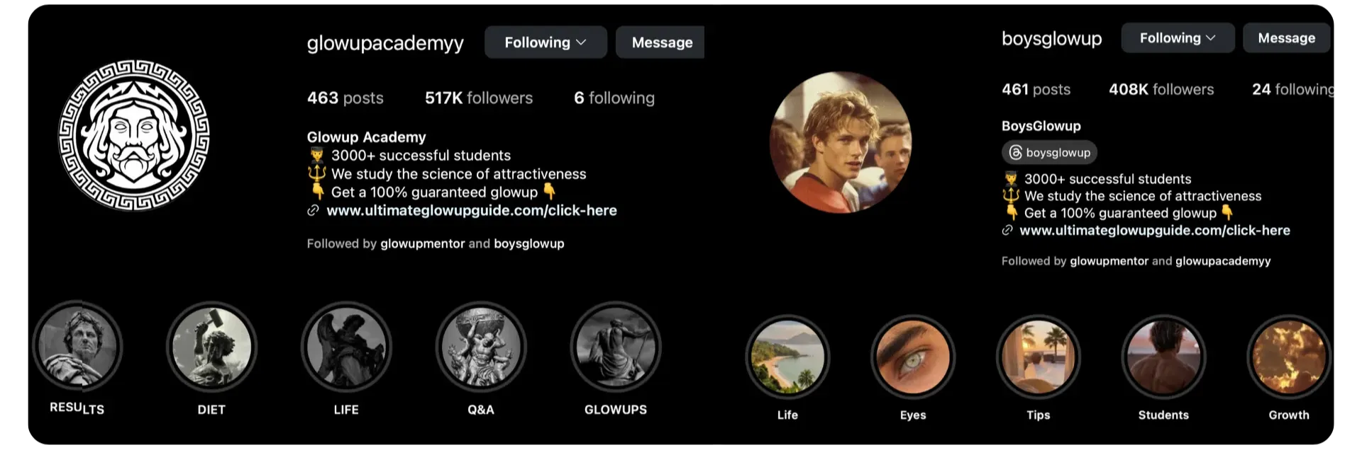 @glowupacademyy or @boysglowup 👇🏼

But what I’m more proud to share is the fact that as my business is fully automated - I’ve been able to dedicate my time to helping everyday people add an extra income stream with the power of Shadow Pages…

And now we’ve grown our community of students to more than 800+ people, where we help each other grow and generate cashflow with Shadow Pages.

Here’s a quick video of what our students have to say…

<https://youtu.be/AvYlOzcVLOk?feature=shared>

**And some of our recent case-studies - I’m extremely proud to share:**

**Dino went from working a 9-5 at a restaurant to making $36,000 per month...**

Not too long ago he was working a 9-5 as restaurant manager, having no freedom and working long over hours...

Then he started working with us and just a couple of months afterward he made over $36,000 in just one single month with his Shadow Page and gained over 500K followers.

Now he is now able to do whatever he wants, live on his own terms and was able to turn his passion for fitness into profit.

<https://player.vimeo.com/video/1028554195?share=copy?autoplay=0&title=0&byline=0&wmode=transparent&autopause=0>

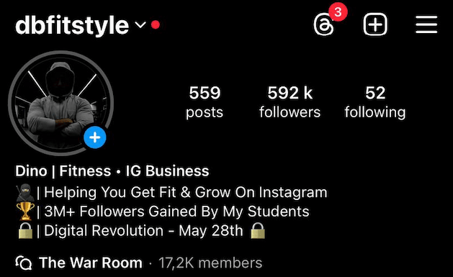

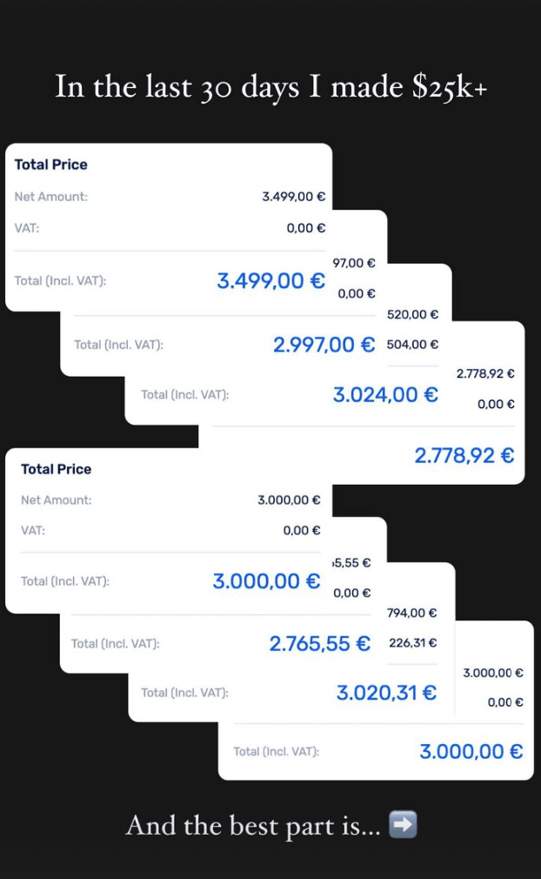

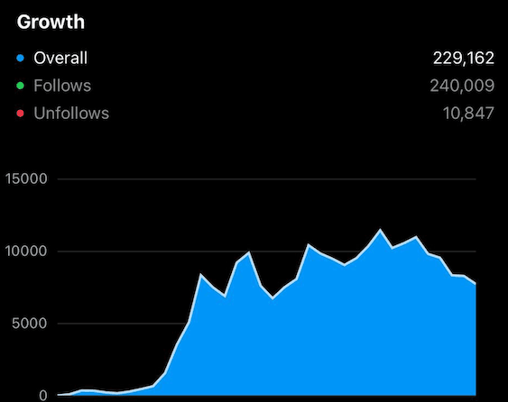

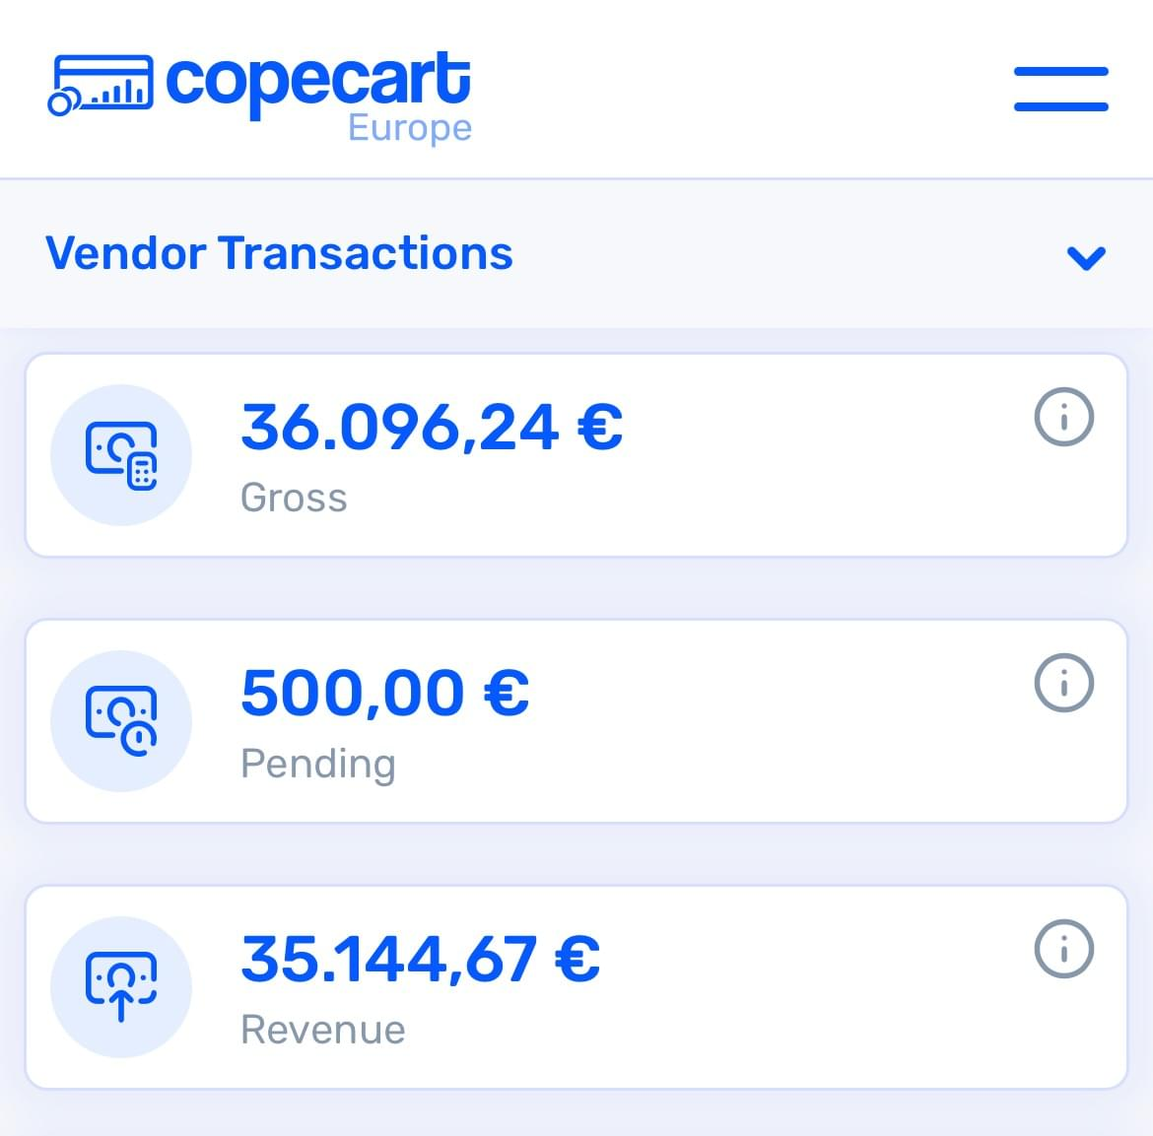

**Amelie makes an extra $3K-$5K a month passively next to her corporate job…**

Having one income stream is scary in today's day and age. Amelie decided she didn't want to rely on one income stream anymore.

She wanted to become financially free, travel and live life more comfortably without having to worry about the next paycheck. Since we started working together she was able to add an extra $3K-$5K/mo on autopilot with her Shadow Page.

Now Amelie doesn't have to rely on her job anymore and is completely free...

<https://vimeo.com/1070393300?share=copy>

**Jeppe quit his 9-5 job and his Shadow Page is making him $10,588/mo...**

He went from working a 9-5 sales job to making $10,320 with his Shadow Page @wealthyparty and quitting his job after working with us for just 3 months.

Now he is traveling with his girlfriend, doing whatever he wants and is fully free. While these results are amazing... it shows you the power of Shadow Pages!

<https://player.vimeo.com/video/1028554164?share=copy?autoplay=0&title=0&byline=0&wmode=transparent&autopause=0>

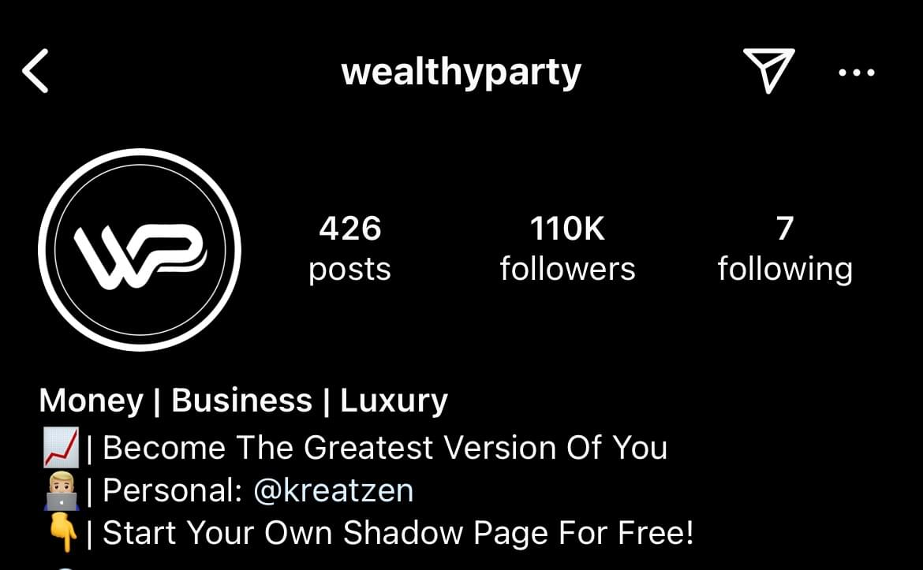

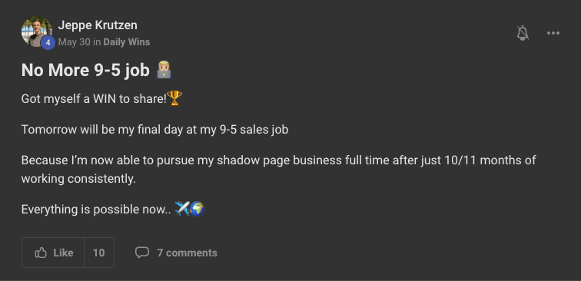

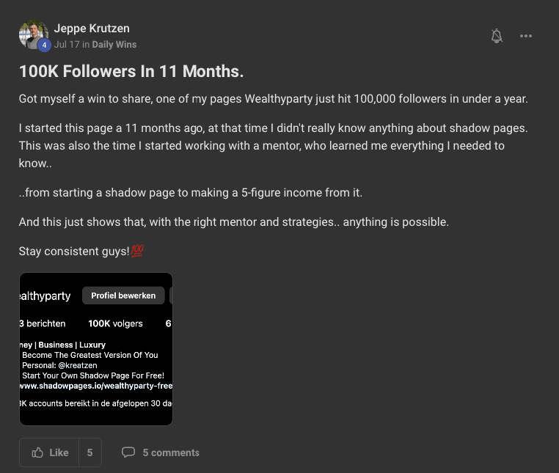

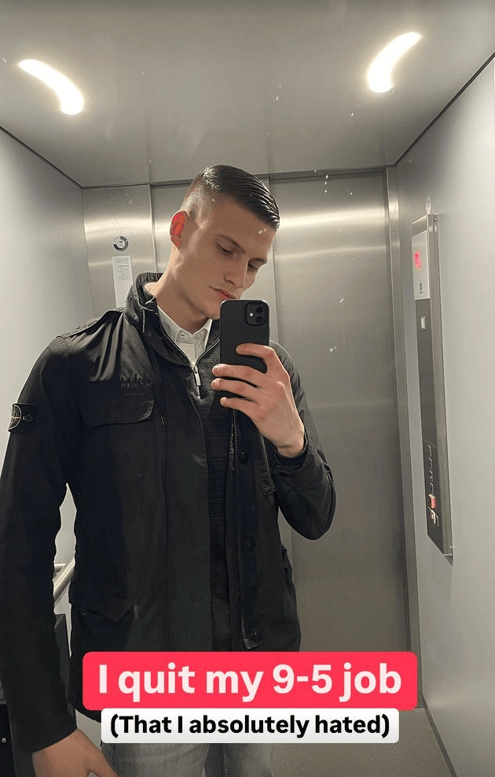

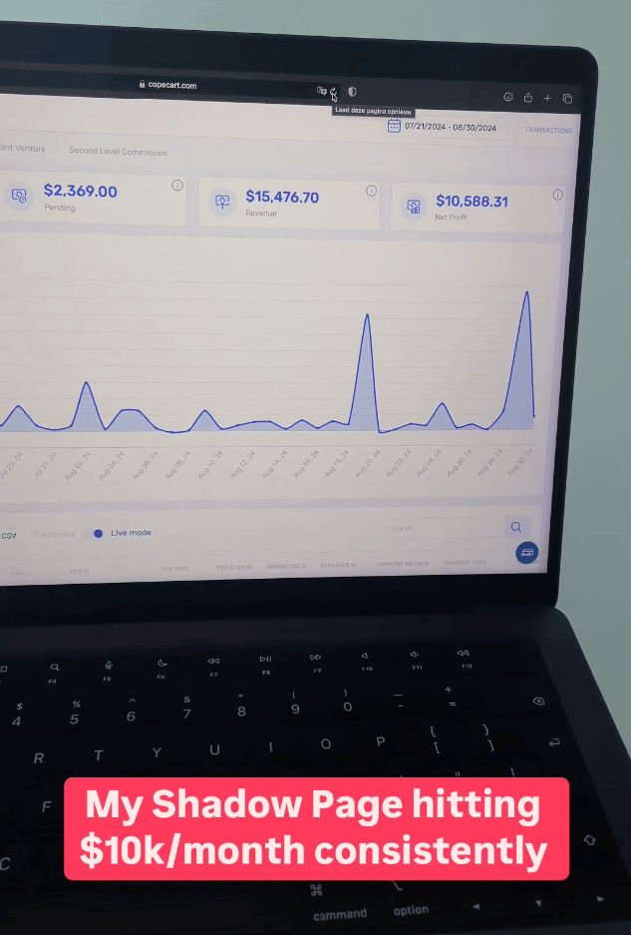



**Ethan makes an extra $15,000 per month with his Shadow Page while university...**

When we started working together Ethan was a normal university student had no idea how to start, grow or make money with Shadow Pages...

He wanted to add an extra stream of income, so he's safe and now his Shadow Page is making him $15,000 per month on complete autopilot.

<https://player.vimeo.com/video/1028904130?share=copy?autoplay=0&title=0&byline=0&wmode=transparent&autopause=0>

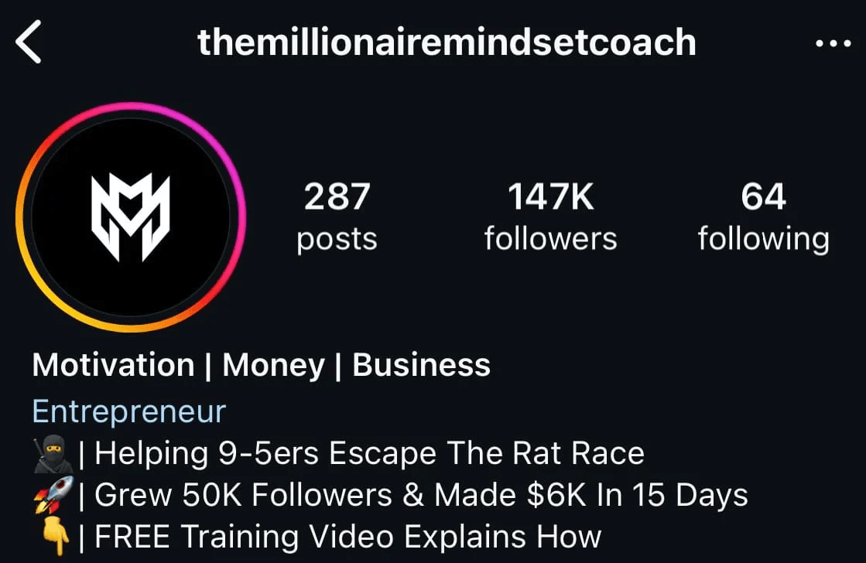

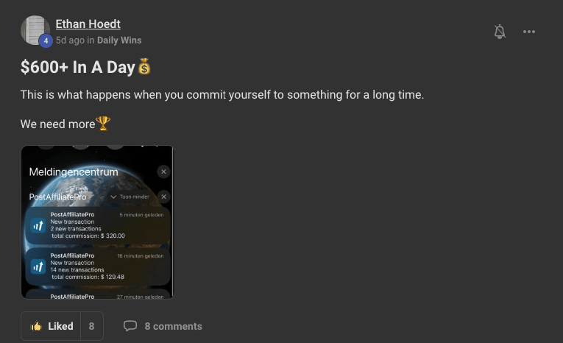

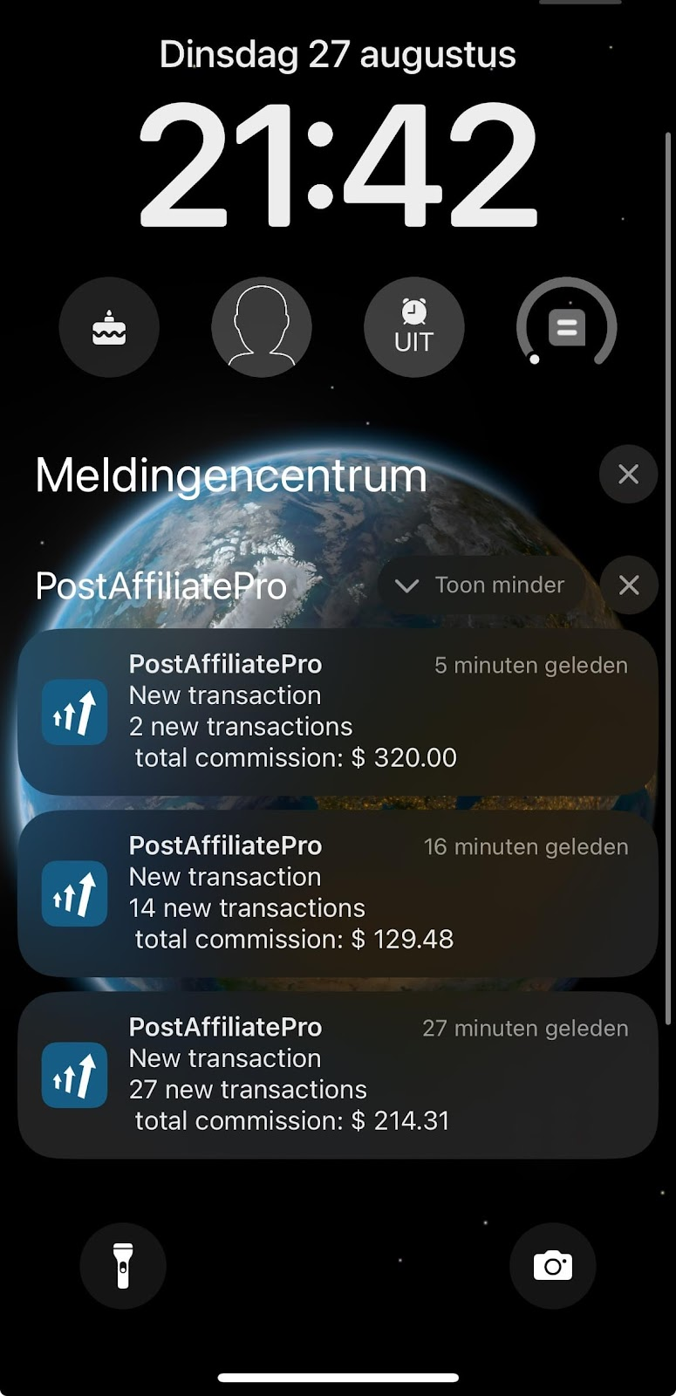

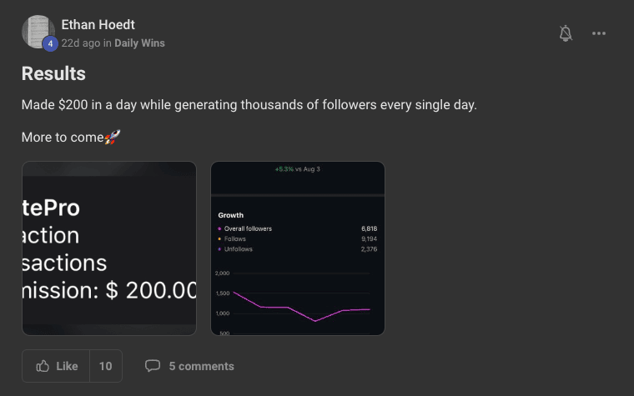

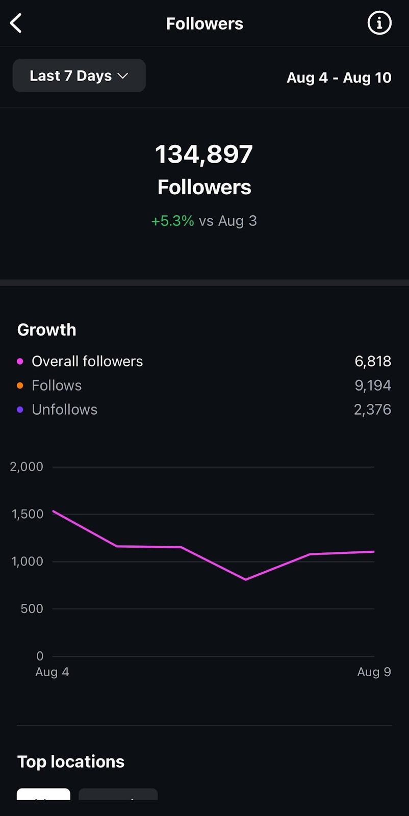

**Now as I know you most likely have a bunch of questions - here’s a quick FAQ that’ll answer most of your questions about Shadow Pages…**

* **Can anyone do this?** Yes. You don’t need tech skills, a following, or experience. If you can follow steps and put in consistent effort, you can build and grow a Shadow Page using proven systems
* **Can I do this next to my job?** Absolutely. Most people start while working full time. Once it’s set up, the system can run in under 30 minutes a day or even less with automation.
* **How long to see results?** Most see income within 1-3 months. With consistent effort, $3k-$10k/month is realistic by month six.
* **Do I need experience?** Nope. Beginners do well with the right system. No personal brand or design skills required.
* **How much time does it take?** Start with 1-2 hours/day. After automation, many manage their page in under 60 minutes a day.
* **Can I automate everything?** Yes. You can automate content creation, scheduling, engagement, and even monetization systems using templates, AI, and a virtual assistant.
* **What niches work best?** High-performing ones include:  
    
  + Mindset & motivation
  + Business & money
  + Relationships
  + Fitness & health  
      
     We help you choose based on what works now.
* **Do I need to show my face?** No. Shadow Pages are fully faceless. You stay anonymous while building a profitable digital asset.
* **What if I’m not creative?** You get plug-and-play content templates, prompts, and scripts. No design background needed.
* **How do I scale past $1k/month?** You stack income streams: digital products, affiliate links, multiple pages, or high-ticket offers. Most students scale with simple systems, not extra hours.
* **How much do you make per shadow page?** Depends on the page. Some pages make $5K/mo others $10K/ mo as you can see it really depends. I know shadow pages generating way more but I like to keep it realistic... Just look at my student @dbfitstyle he was able to make $36K in a single month with his shadow page, so it has a lot of potential :)
* **Can I do it from anywhere in the world?** Yes that's why it's so great... You have an income stream generating you cash flow while you can travel the world, spend more time with your loved ones and have true freedom. I've got students traveling all around the globe from Asia to South America and enjoy their location freedom entirely...
* **I'm not technical gifted can I do it?** Yes 100%, you can do it without any prior experience and you don't have to be technical skilled at all. You won't have to set up a product. You won't have to code. All you need is Instagram and the proper knowledge + guidance.
* **I'm 35+ and working a full time job, do you think I can do it?** Yes 100%, most of my students started their Shadow Page next to their 9-5 job.  
    
   (As it's automated and doesn't require much time)  
    
   My student Dino Edbfitstyle was in his thirties working a miserable job as a restaurant manager and was able to make $36,000 in a single month with his Shadow Page since working with us and quit his job  
    
   So yes you can 100% do it next to your job haha
* **How many shadow pages do you have ?** Over 10+ pages. I know quite a lot, but the fun part is I'm not working at all on most of them.
* **How do you manage it? I am not sure if I have enough time for shadow pages** You can complete automate your page so you don't have to work on it.  
    
   Like I spend less than 5min on my pages and they're generating me Cashflow every single day just because I was able to automate them.  
    
   (Now they're real passive income streams)